1. 
2. 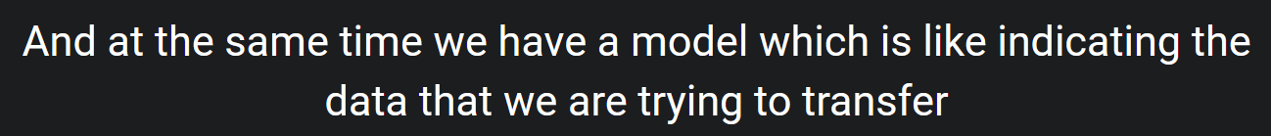
3. 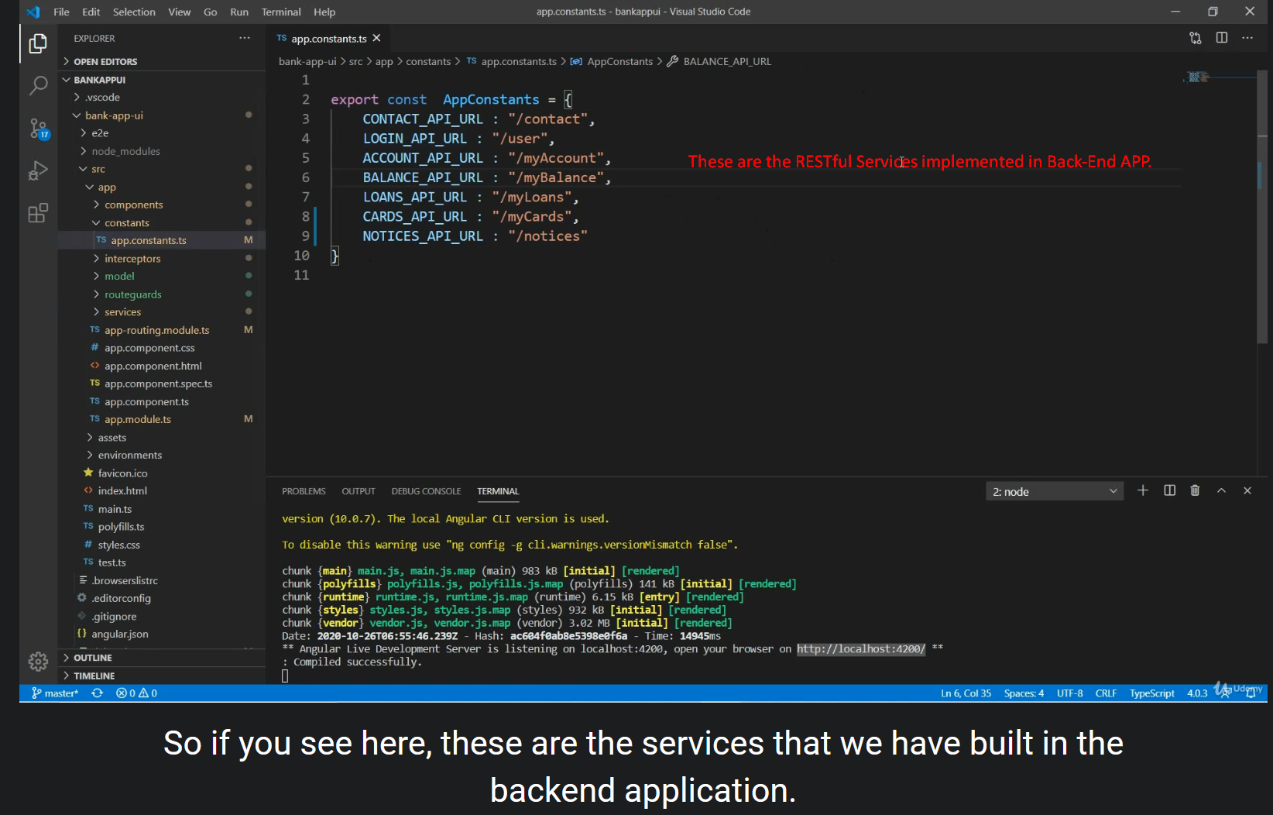
4. Just Walkthrough of the Angular Code.
5. NOTE: watch again.